Session 1

1-find your mac address

1-ipconfig/all command :and that command used to get info about your network adapter

Info like (mac address, ip address, dns server and so on )

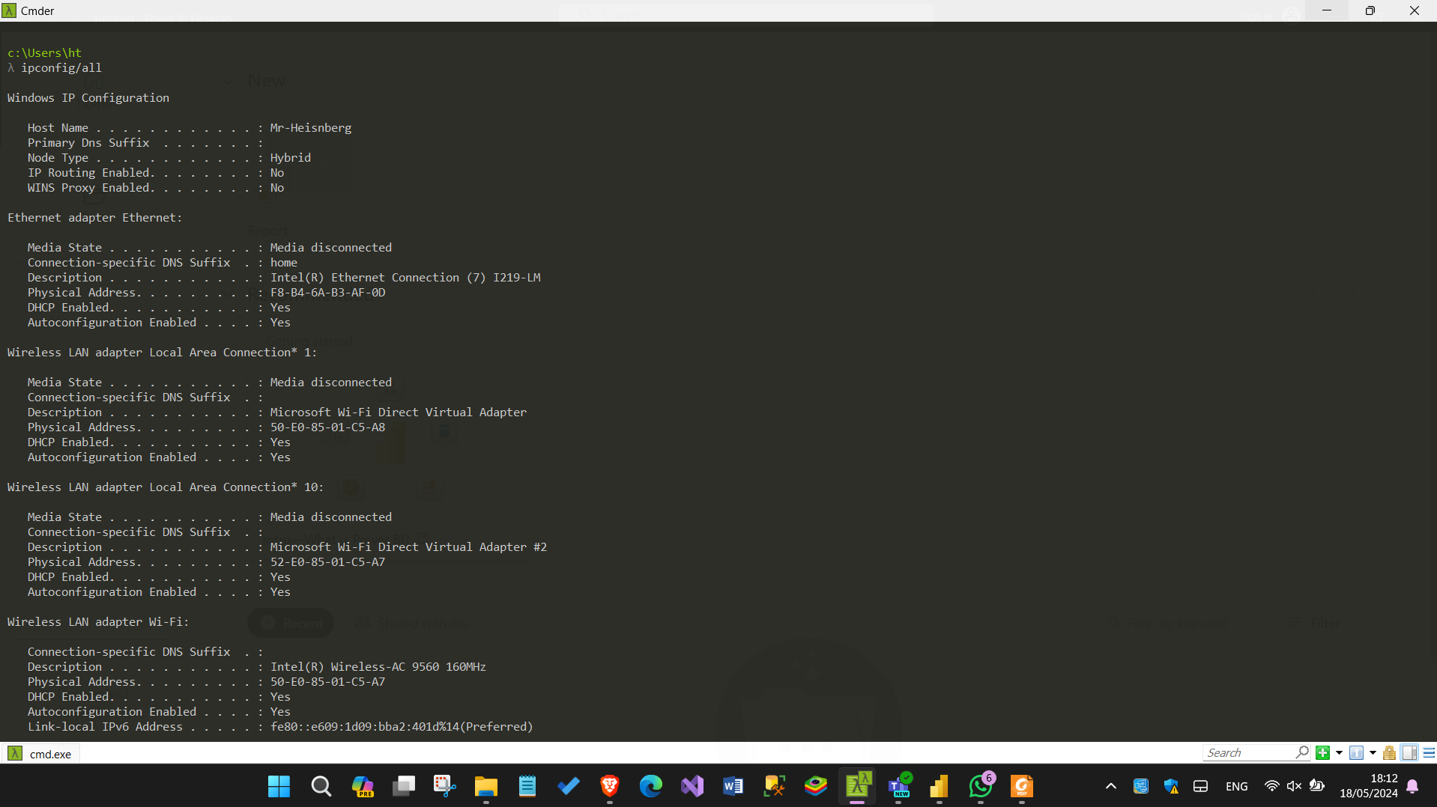

2-Getmac :and that command used to display the physical address for your computer

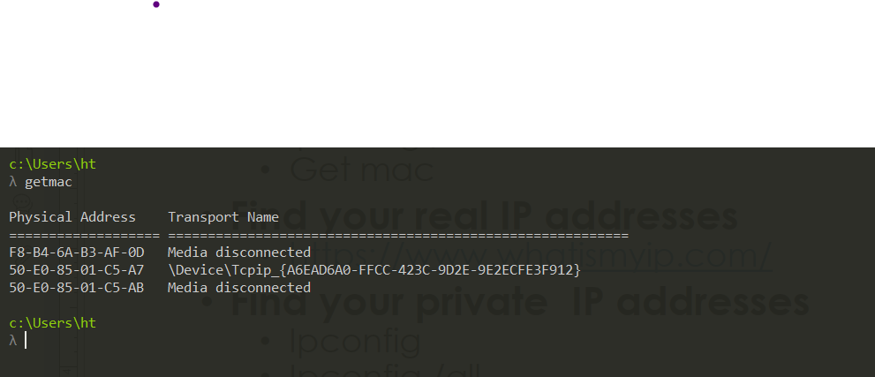

2-find your real ip addresses

From that sit ([https://www.whatismyip.com/)](https://www.whatismyip.com/):that)

And that site help you to get your current ip

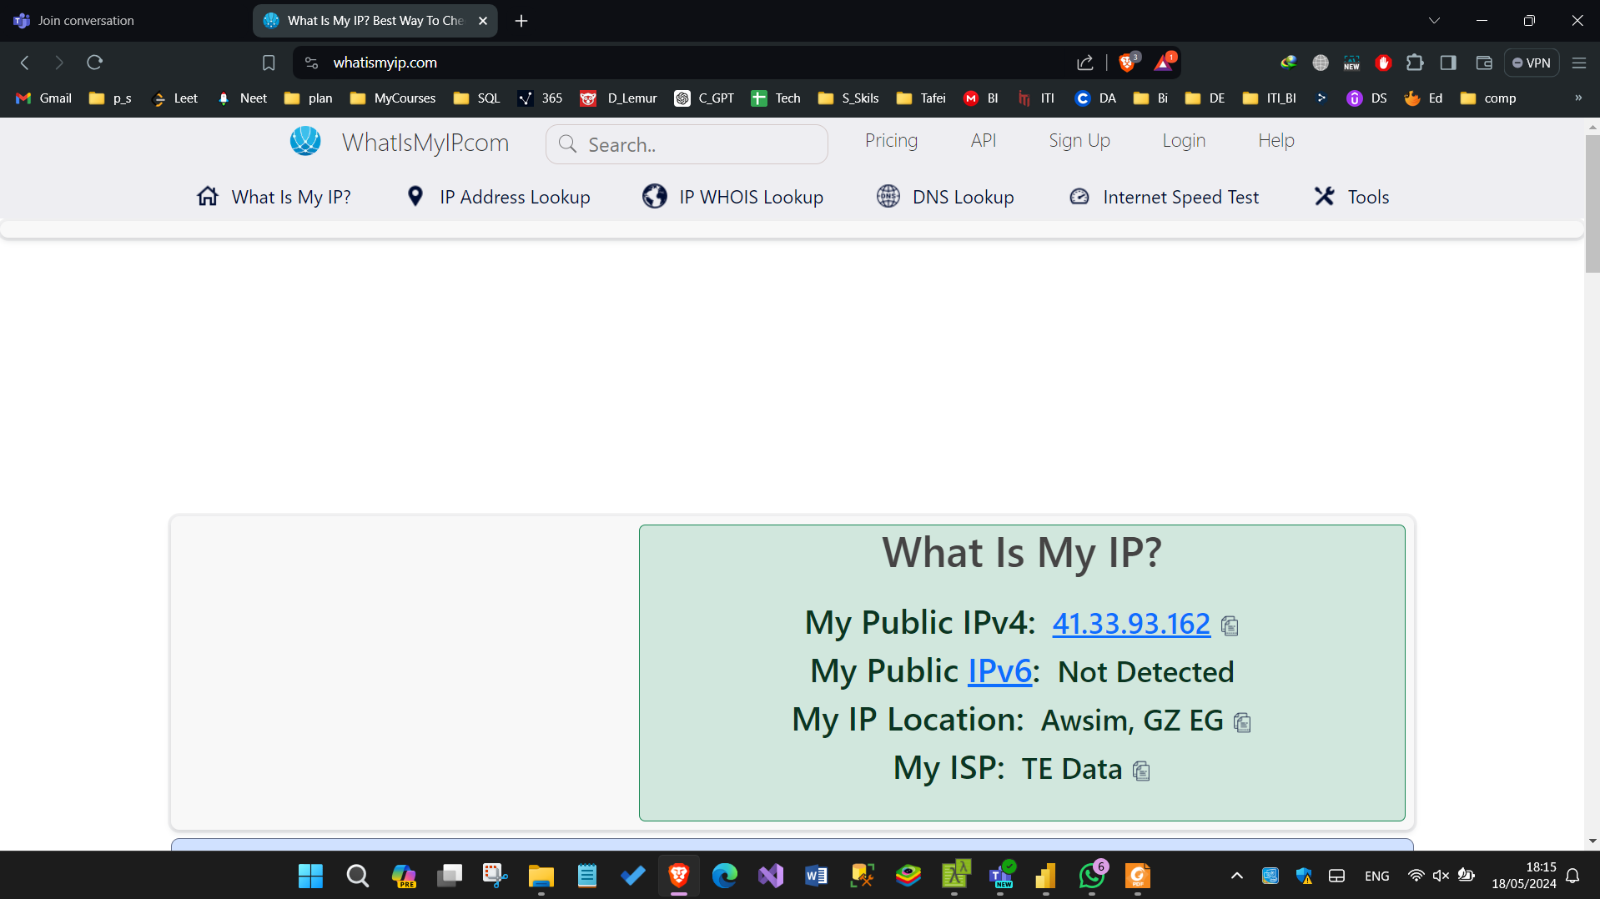

3-find your private ip addresses using the following command

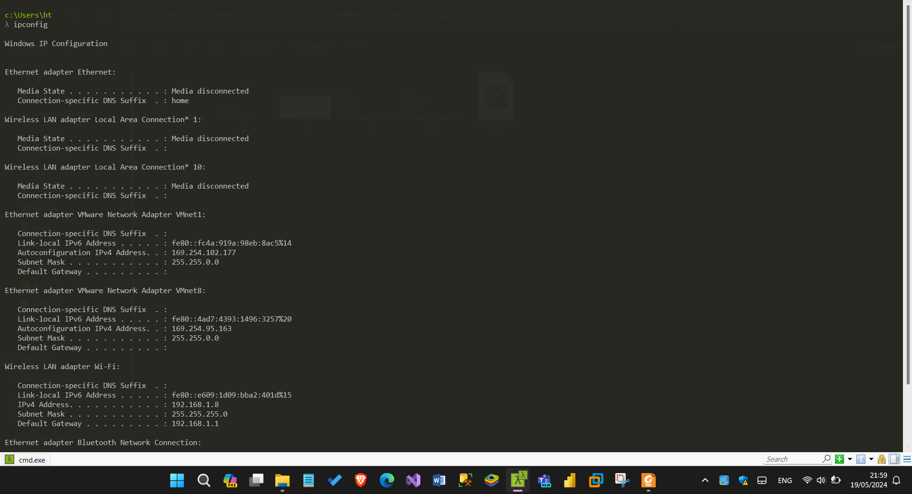 1-ipconfig:and that get also info about the network you connected with it

 2-ipconfig/all: and that like we said above get info about your network with more details

3-ipconfig/release : that command used to release (stop using the current ip) and that we

Used it in many cases like in trapshooting

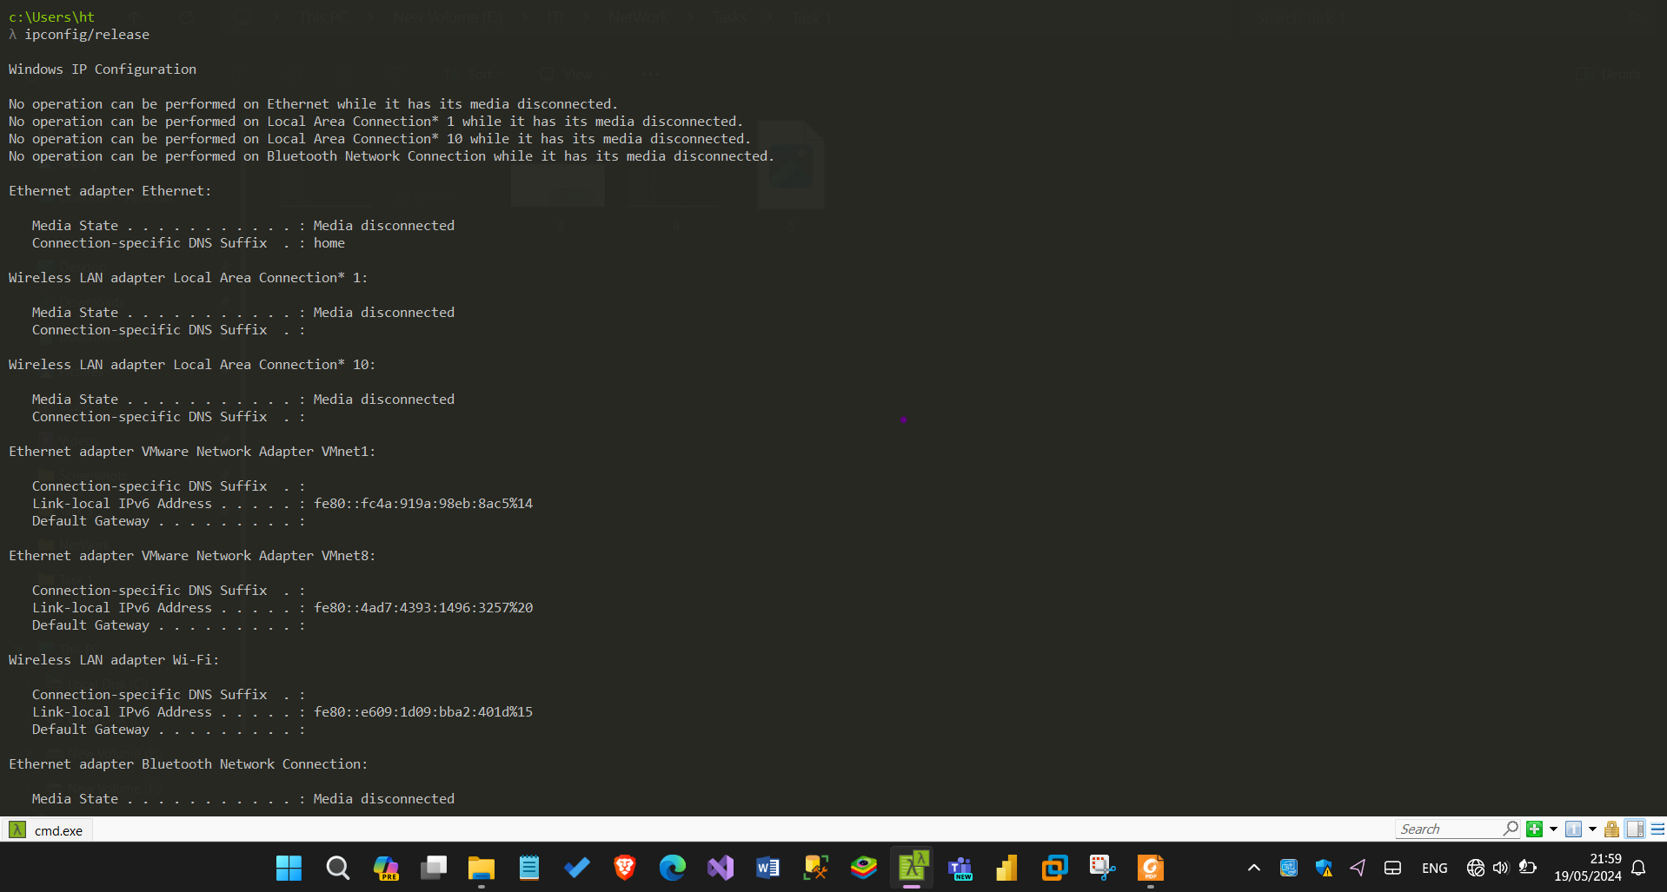

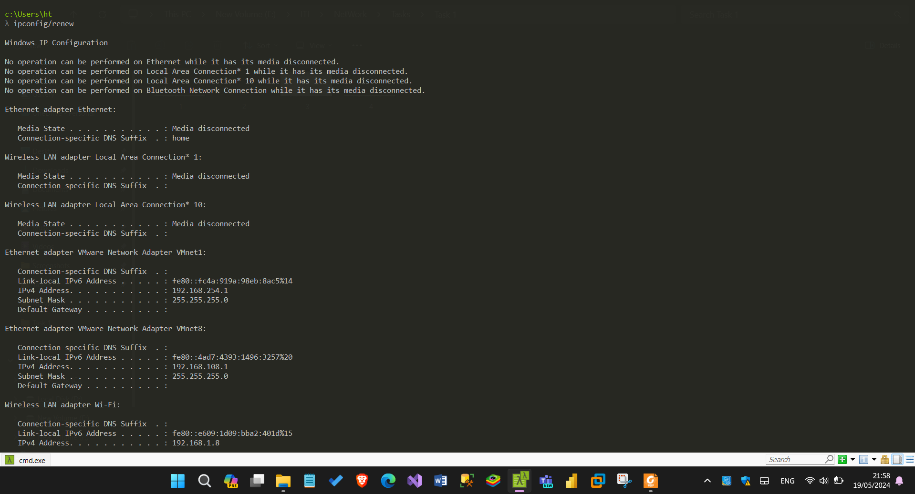 4-ipconfig/renew :and that we used it to get a new ip

4-Find current session and ports on your device

Using the following commands

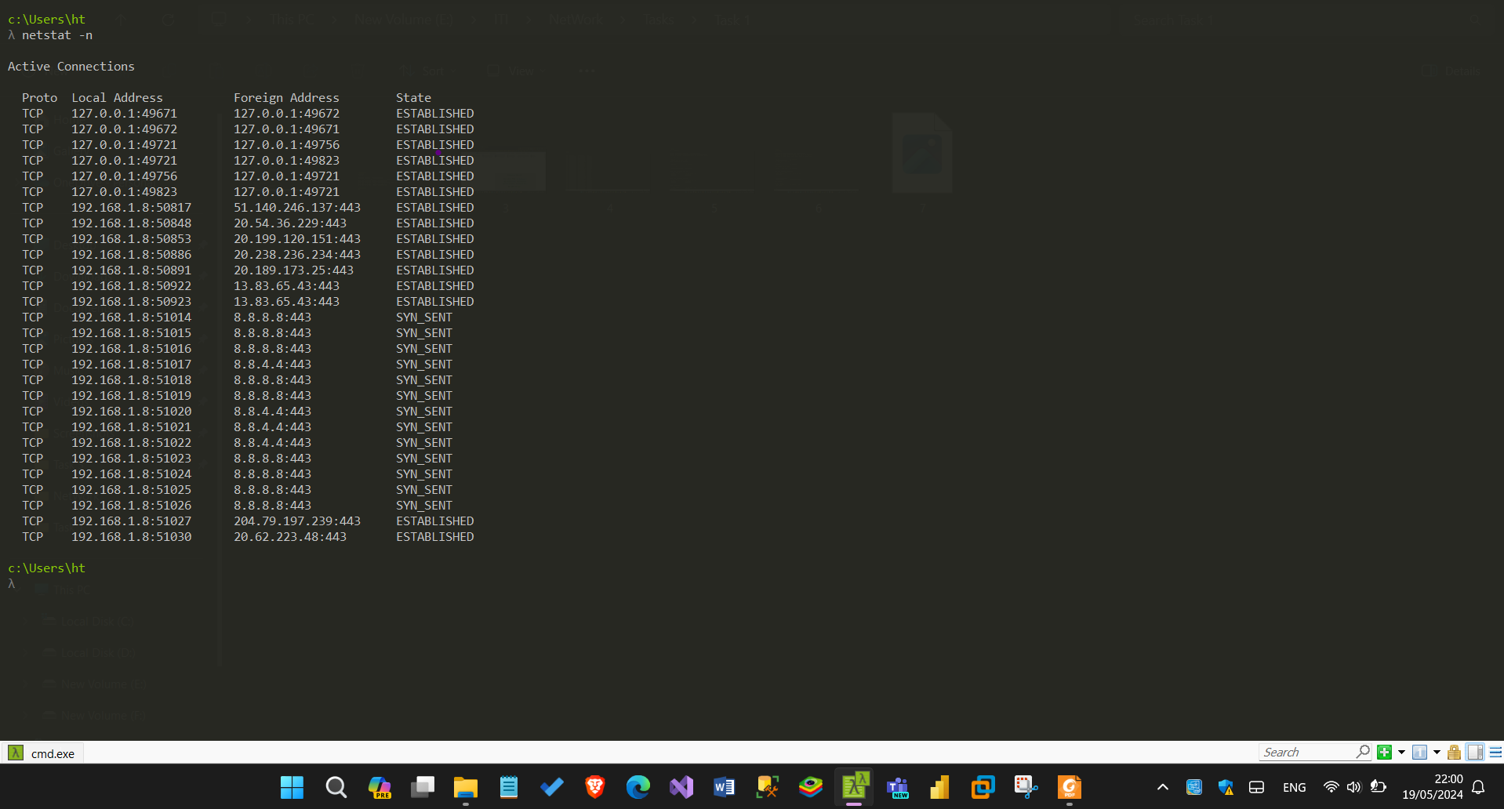 1-netstat -n :and that used to get the network status.

2-netstat -a :also get the network statue, and Shows all active connections and listening ports, includes DNS resolution

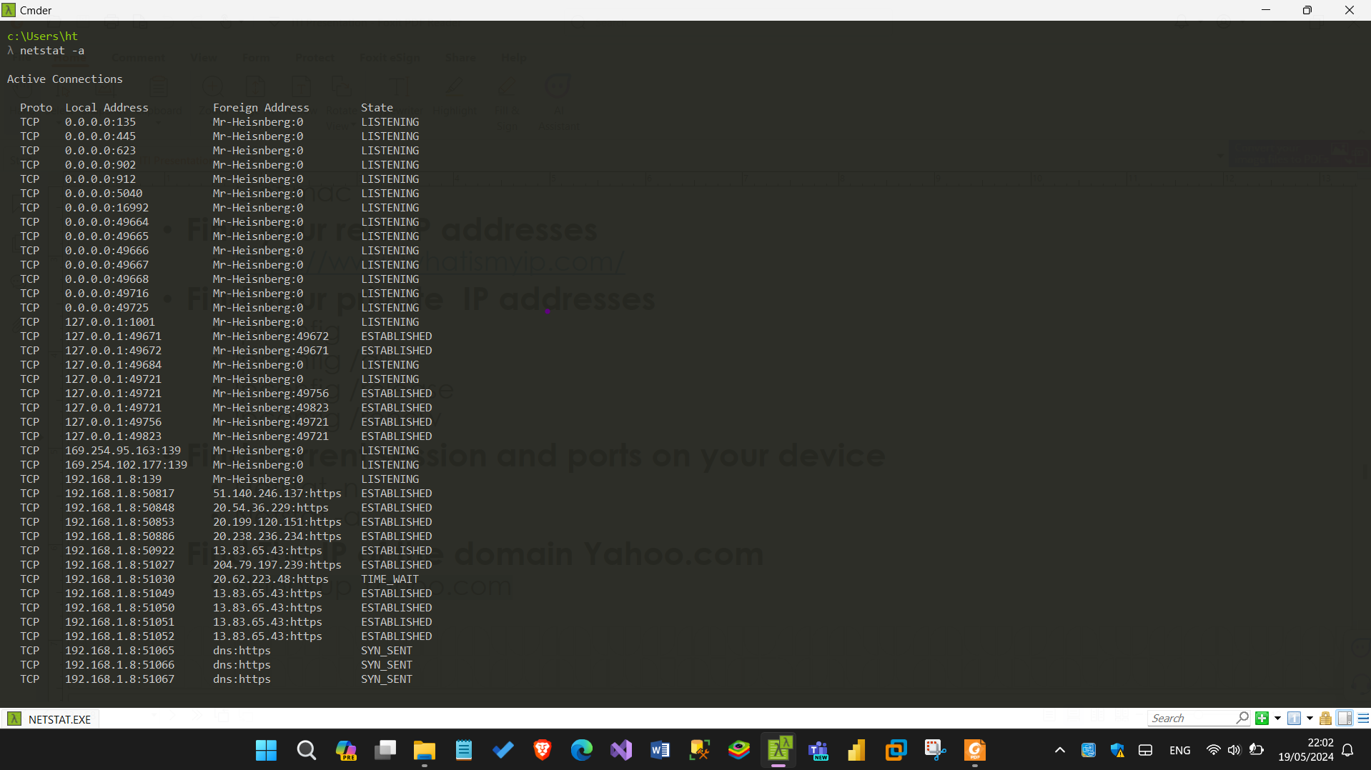

5-Find The IP of the domain Yahoo.com

Using the following command : nslookup yahoo.com

